Anatomy
Student’s Name
Institutional Affiliation
Date

Anatomy of the respiratory system [lungs]
The concept to be discussed under anatomy of the respiratory system is the lungs. The lungs are paired organs located within the thoracic cavity. They are the major organs of the respiratory system. In terms of size and structure, the left one is smaller than the right one and is made up of three lobes (Effros, 2006). These are the superior lobe, the middle lobe and the inferior lobe. The lobes are separated by two fissures; the oblique and horizontal fissure. The smaller lung, the left one, has got just two lobes, the superior and inferior one which are separated by one oblique fissure. During breathing, air moves through the trachea and bronchi and fills tiny air sacs called alveoli. Alveoli are surrounded by capillaries and the thin membranes of alveoli facilitates passage of oxygen. Lungs are the main organs of breathing in human body. It is the organ where gas exchange occurs.
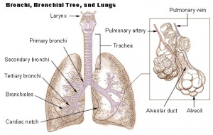
Mechanics of breathing [Breathing in]
Inspiration (breathing in) is a complex process. It involves air entering from the external environment into the lungs. The diaphragm is the organ that carries out breathing. During inspiration, the diaphragm elongates hence reducing chest cavity (Effros, 2006). The diaphragm flattens pulling lower surfaces of the lungs downwards. The rib cage is elevated by the muscles involved in breathing in. The external inter-costal muscle is one of the main muscles. After lifting the ribs and pushing down all the abdominal, the volume increases in the inter-thoracic cavity. A fairly constant negative pressure is generated in the pleural cavity due to the lung’s tendency to collapse in the direction of the hilum as well as the attachment to the thoracic wall by the parietal pleura. This is the organ that connects the lungs to the visceral pleura. During inhalation, the lungs are filled with oxygen and they expand. This lowers intrapulmonary pressure relative to external pressure. Consequently, air flows from a high pressure zone to a low pressure zone, making it to move into the lungs (Effros, 2006).
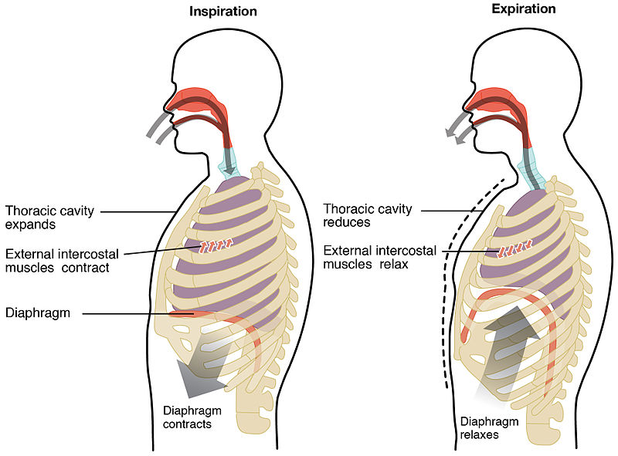
Respiration [Anaerobic respiration]
Anaerobic respiration is one which does not require oxygen (Wiebe et al. 1981). Instead of molecular oxygen, anaerobic respiration uses electron acceptors. When a person does or undertakes straining hard exercises, oxygen though inadequate, can reach your muscle cells. In the absence of oxygen, the electron transport chain (ETC) is not able to continue as there is no terminal electron acceptor. Therefore, the number of ATP molecules cannot be generated. Hence, aerobic respiration is foregone and anaerobic respiration takes place. The anaerobic pathway uses pyruvate, glycolysis’s final product. This does not require oxygen in order for it to occur. Due to this, anaerobic respiration does not produce as much energy as aerobic respiration. During anaerobic respiration, glucose is broken down into lactic acid although not completely.
The equation for anaerobic respiration is as follows:
Glucose → lactic acid
C₆H₁₂O₆ → 2C₃H₆O₃
Lactic acid is the waste product of anaerobic respiration. This acid builds up in muscles which results to pain and tiredness, and consequently cramps. Anaerobic respiration occurs in organisms such as bacteria and fungi. This is because such organisms need to release energy from glucose. Unicellular fungi such as yeast also carry out an aerobic respiration known as fermentation (Müller, 2001).

References
Effros, R. M. (2006). Anatomy, development, and physiology of the lungs. GI Motility online.
Müller, V. (2001). Bacterial fermentation. e LS.
Wiebe, W. J., Christian, R. R., Hansen, J. A., King, G., Sherr, B., & Skyring, G. (1981). Anaerobic respiration and fermentation. In The ecology of a salt marsh (pp. 137-159). Springer, New York, NY.

